

School of Computer Science Engineering and Information Systems Winter Semester 2025-26

Agile Development Process and DevOps Lab ISWE406P

MID-TERM

Name: Madhumitha B Reg.no: 23MIS0360
Slot: L47+ L48

QUESTION: The Login Authentication System ensures that users can log in securely using correct credentials.

It validates username and password and allows access only if the credentials are correct.

OBJECTIVES
- Develop login validation logic using Java
- Perform unit testing using JUnit
- Implement CI/CD pipeline using Jenkins
- Deploy application using Docker and Kubernetes
- Push project to GitHub

TOOLS USED
- Java
- JUnit
- Jenkins
- Docker
- Kubernetes
- GitHub
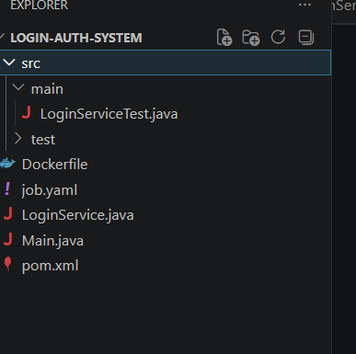

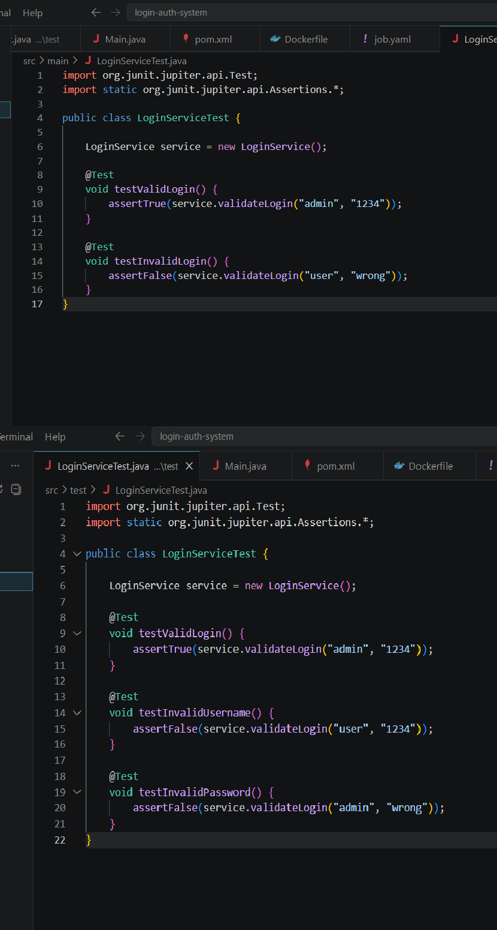

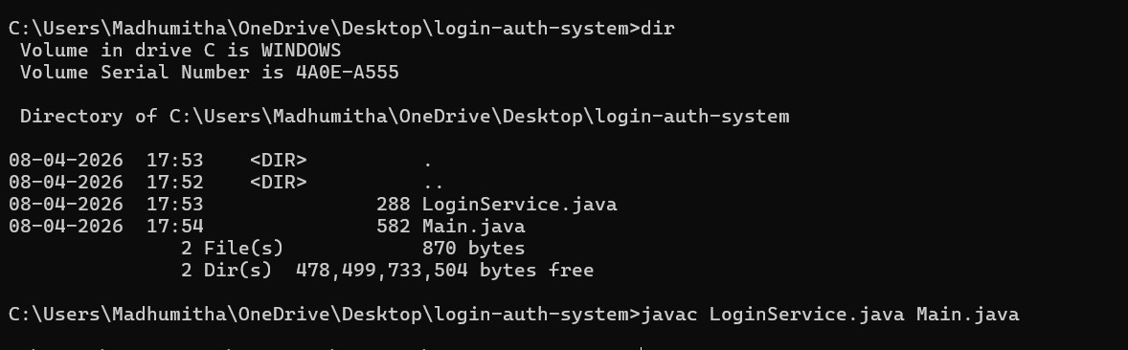
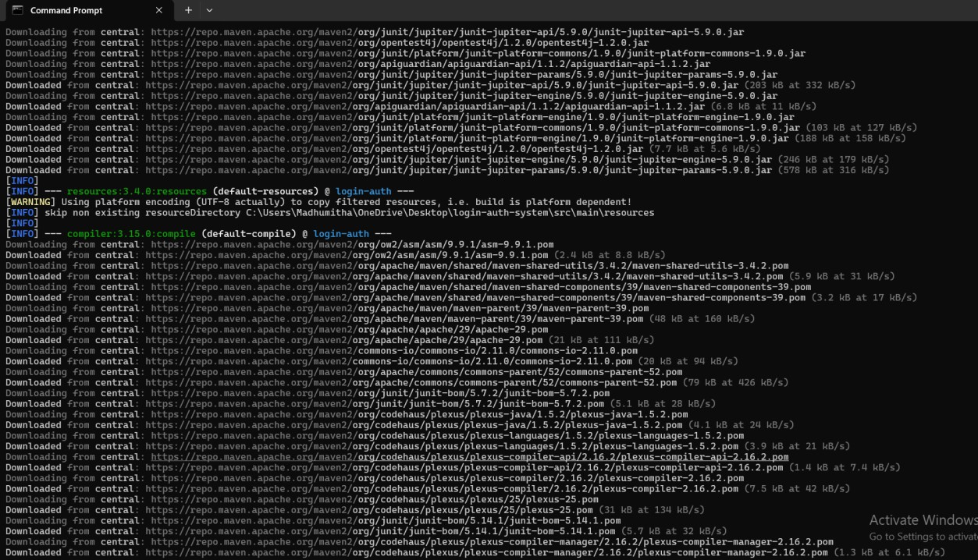
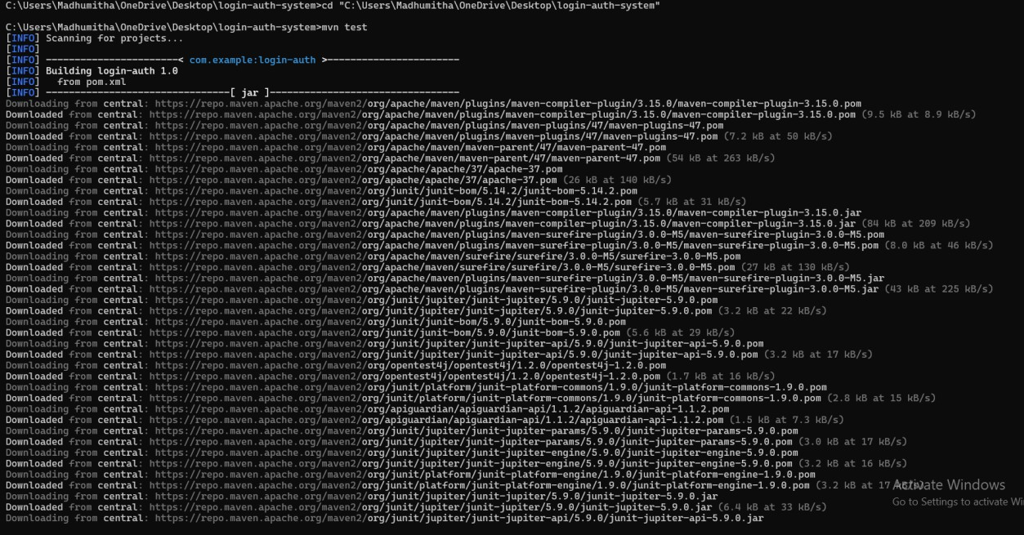

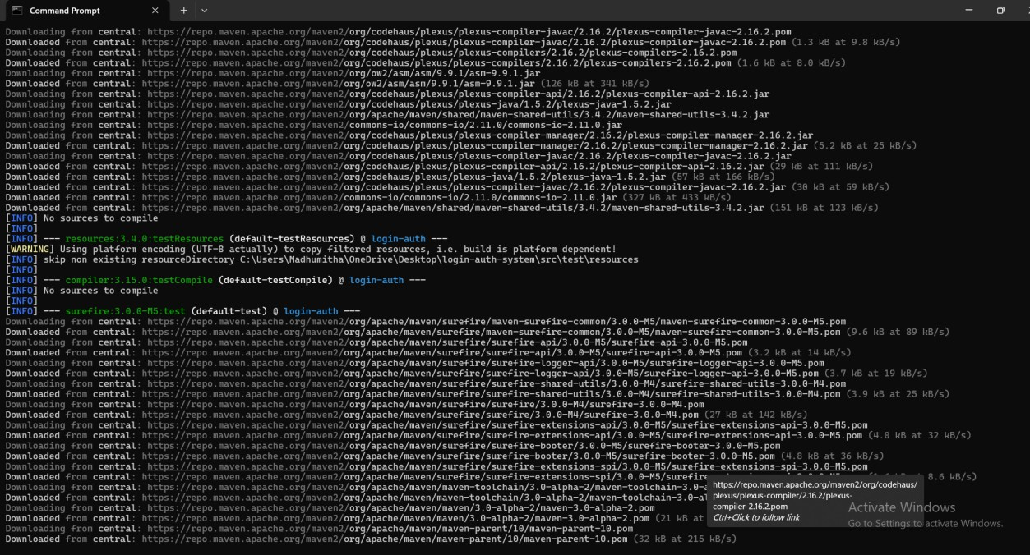
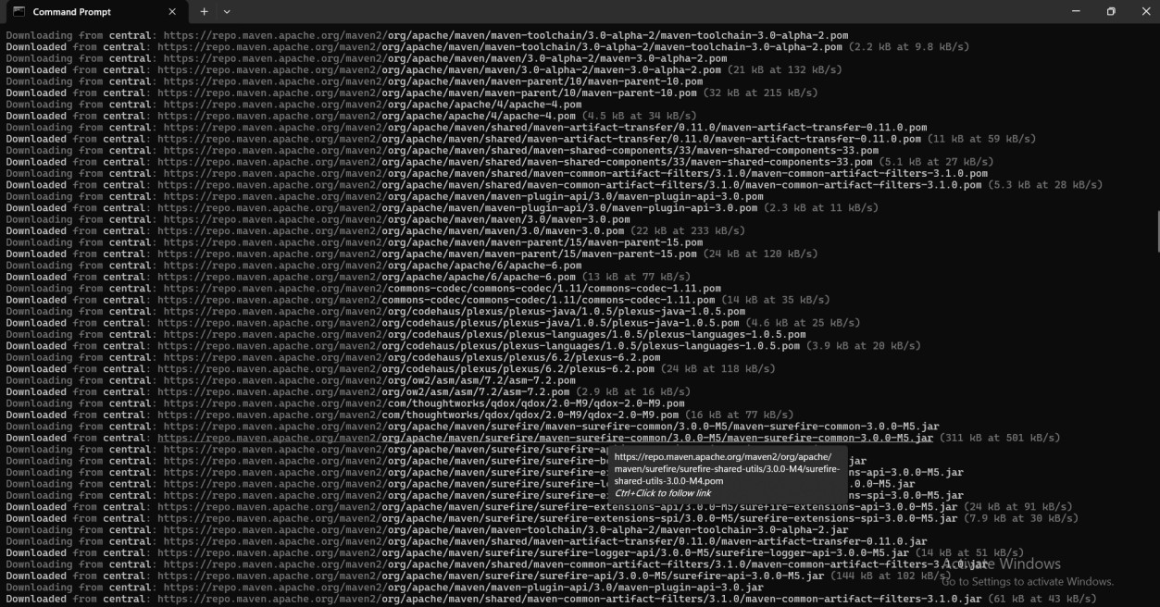
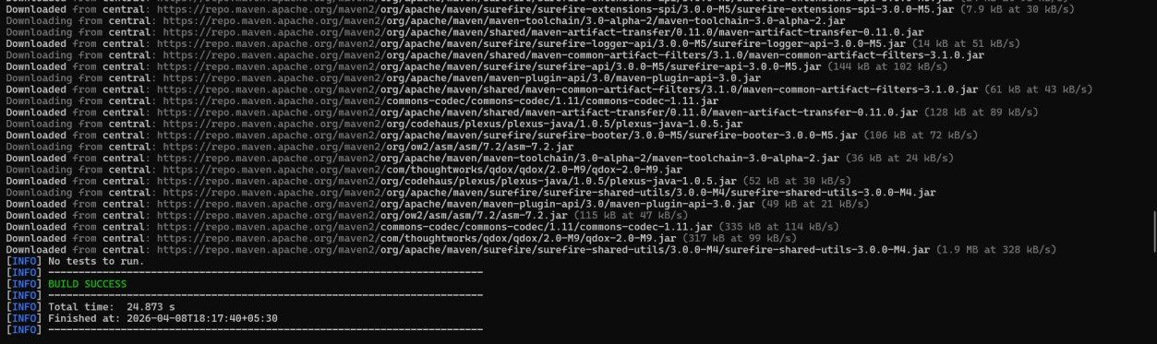

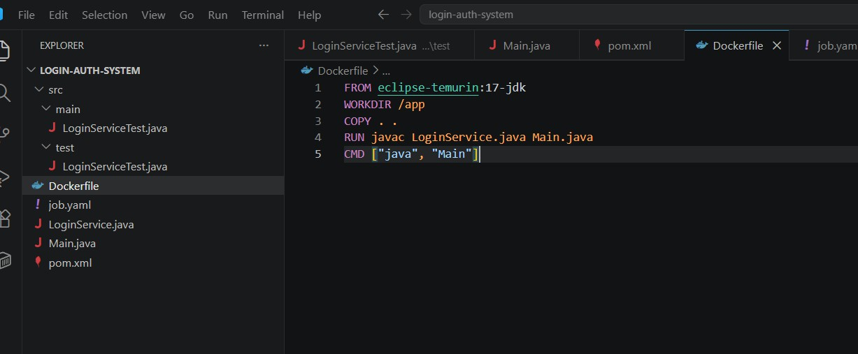
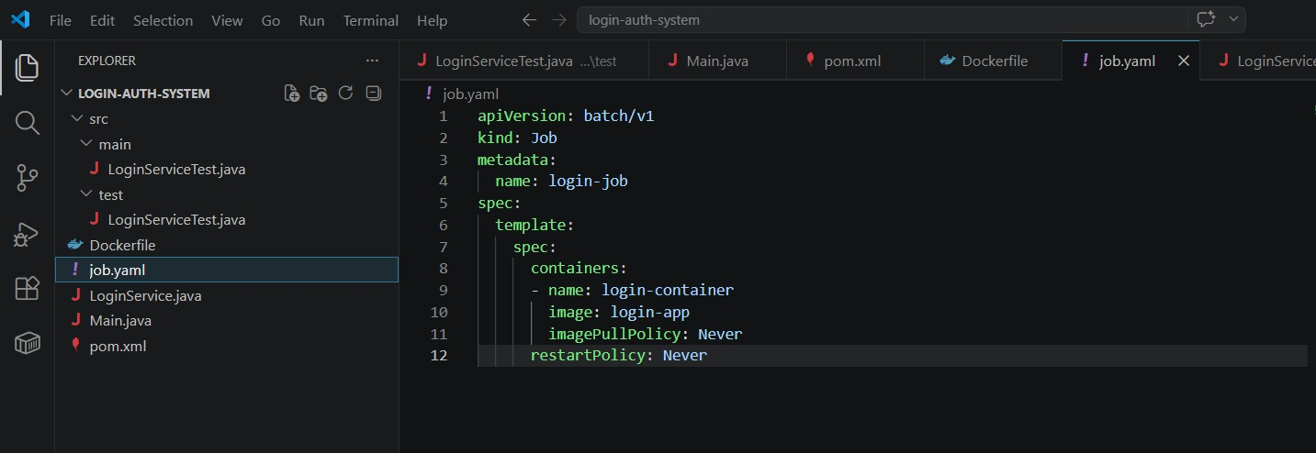
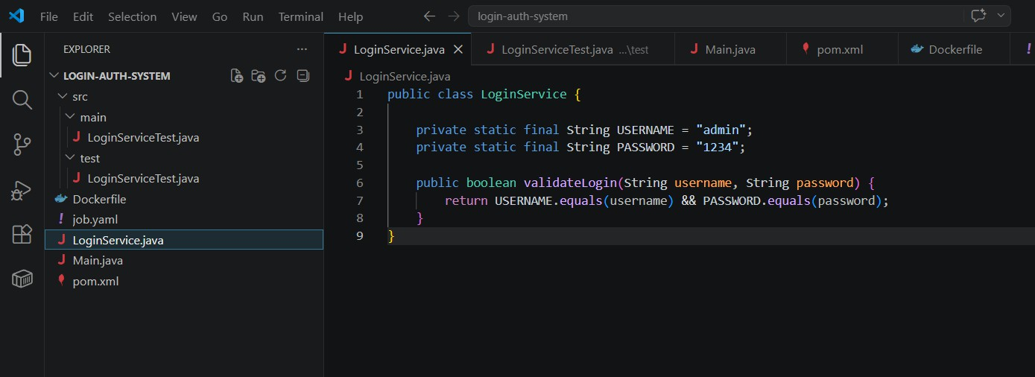

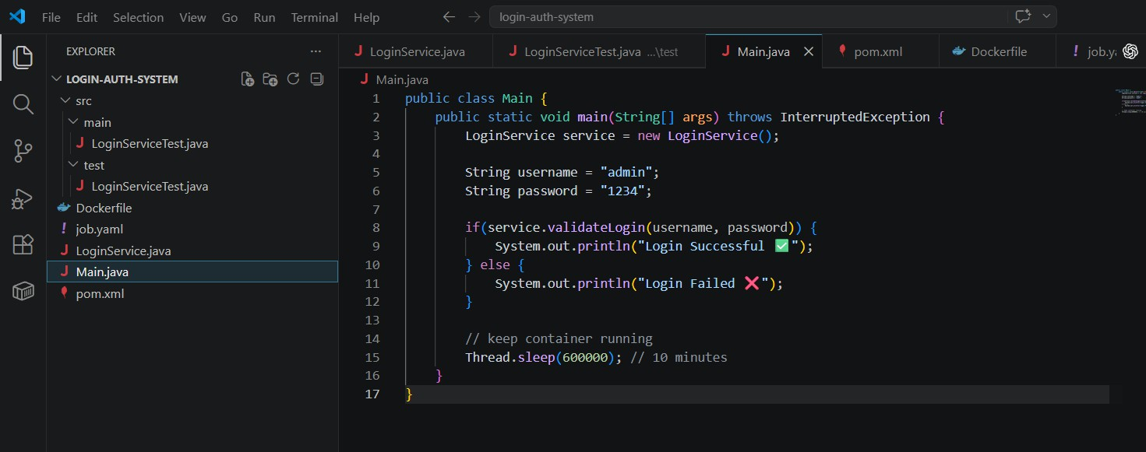
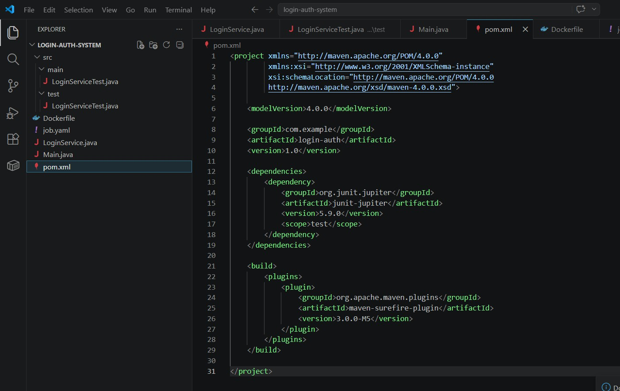

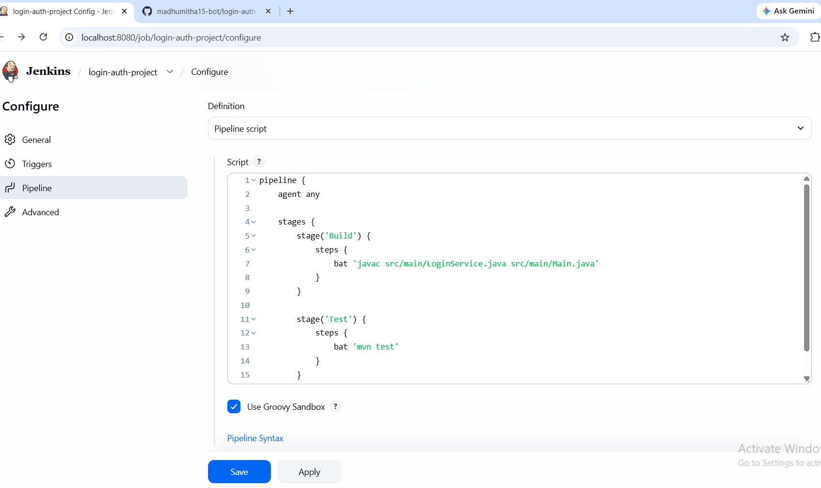
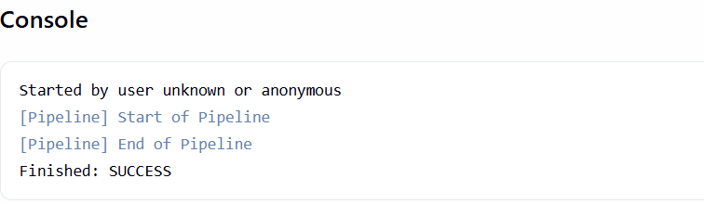

DOCKER:
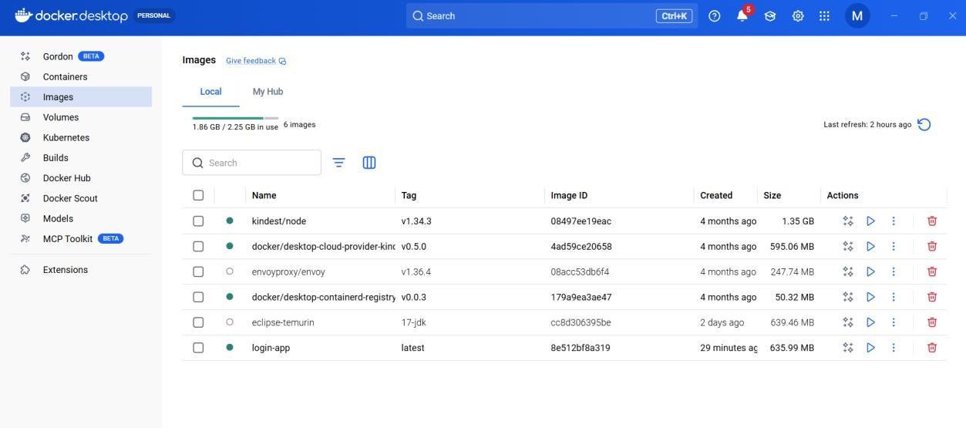

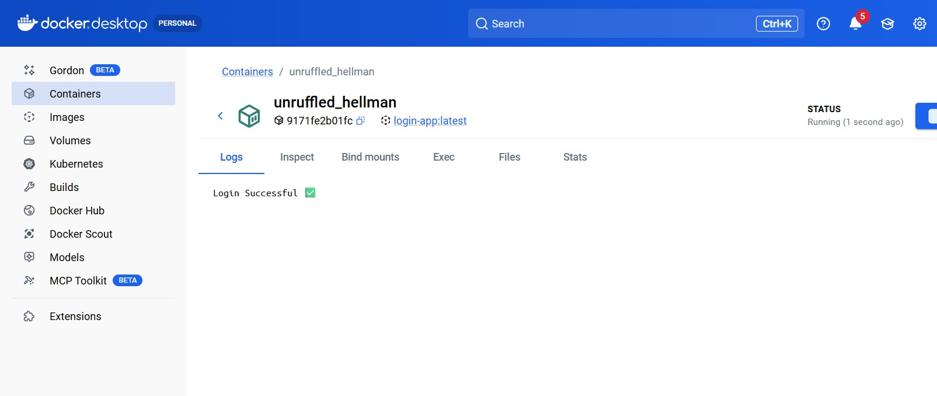

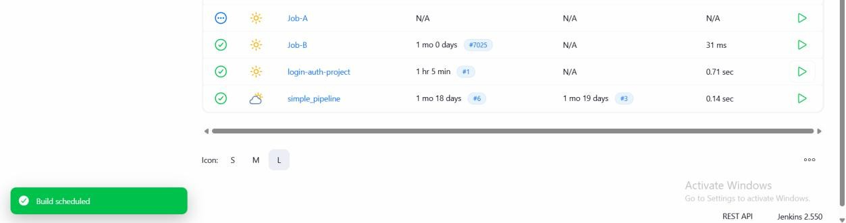
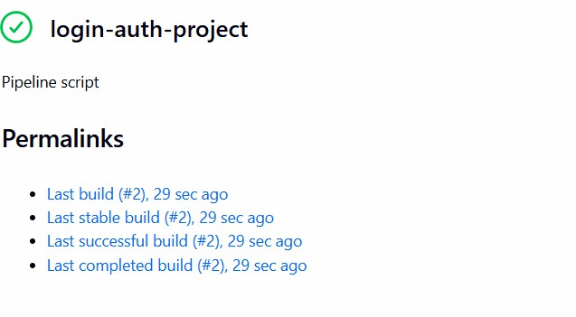
KUBERBETTES:

